**Check our Docker Install and config:**

1. systemctl start docker
2. docker version – Need to check whether the docker can talk to client.

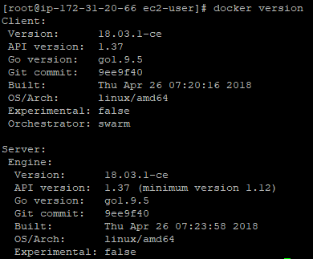

1. docker – Gives you the list of command that can be executed

format: docker <command> <option>

1. docker info – Shows most configuration info value for the engine

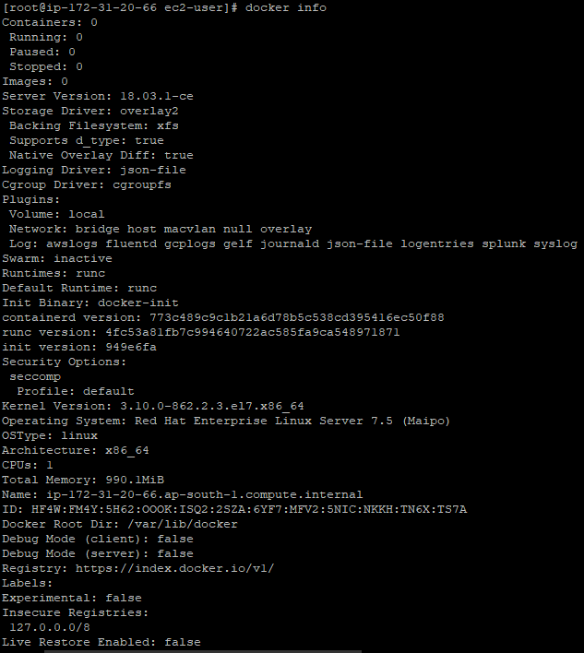

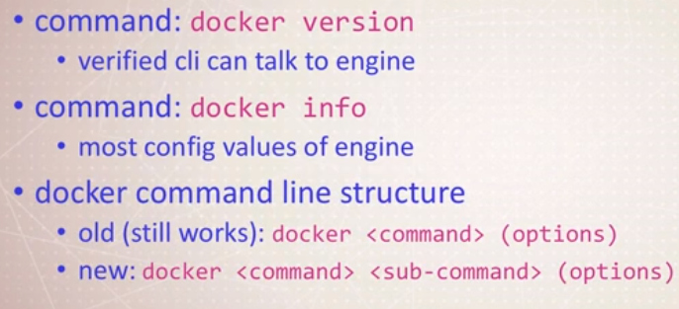

**Starting Nginx web Server:**

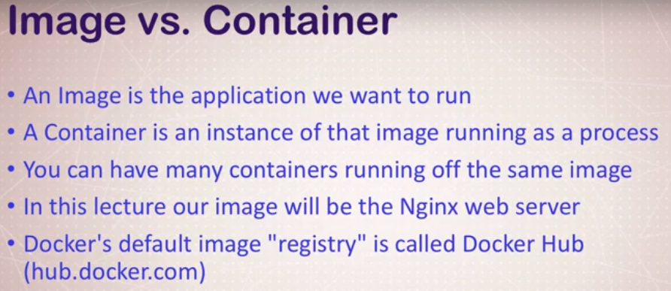

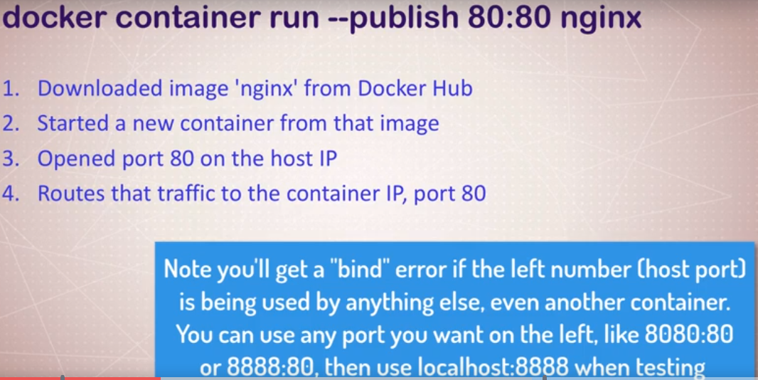

**Commands:**

docker container run –publish 80:80 nginx

docker container run –publish 80:80 –detach –name webhost nginx

docker container stop webhost

docker container ls -a

docker container logs webhost

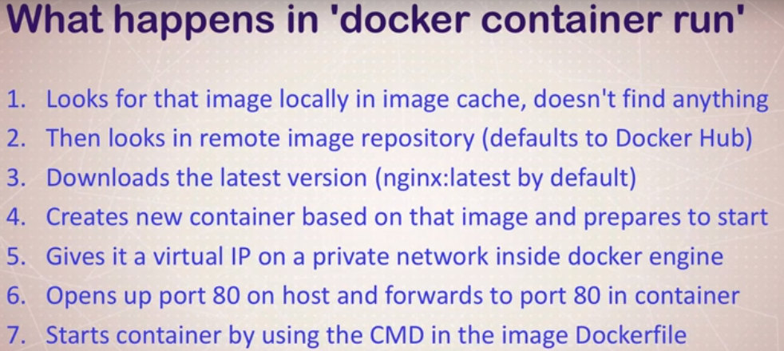

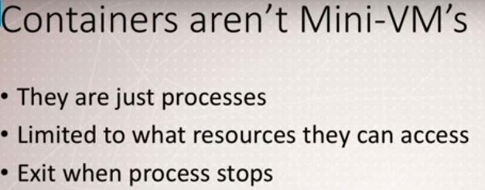

docker top – list running processes in specific container



Running mongodb - docker run --name mongo -d mongo

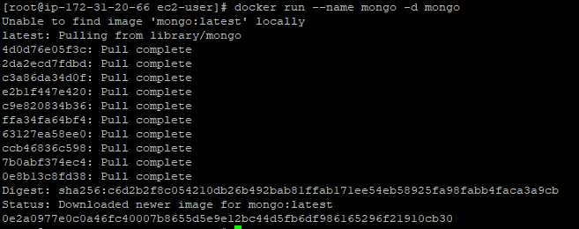

**Mongo start/stop**

docker stop mongo



docker start mongo



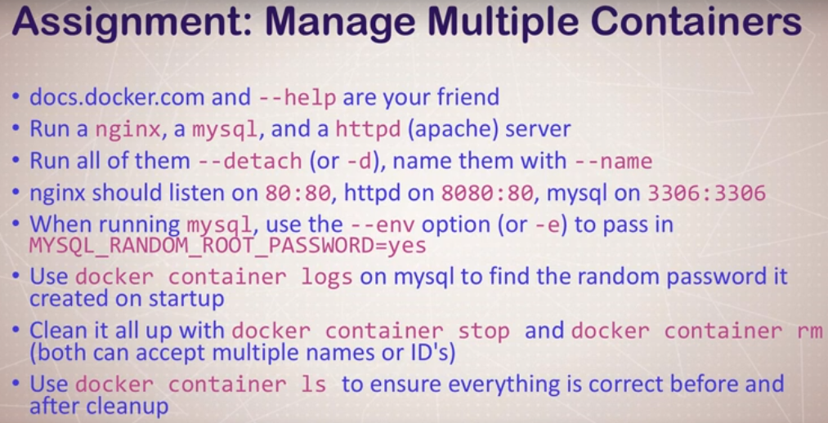

**Solution:**

docker container run --publish 3306:3306 --detach -e MYSQL_RANDOM_ROOT_PASSWORD=yes --name db mysql

Note: for root password check the log using following command



Log snippet containing the password

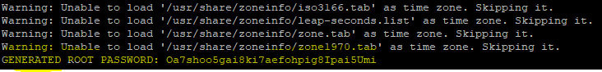

docker container run --publish 80:80 --name nginx --detach nginx

docker container run --publish 8080:80 --name httpd --detach httpd

Stopped -

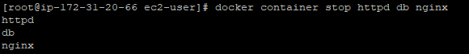

Removed-

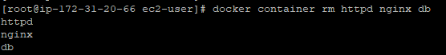

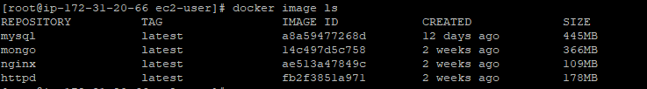

docker container top mysql

docker container top nginx

docker container inspect mysql – Shows metadata about the container (startup, config, volumes, networkings, etc.)

docker container stats – shows live performance data of the running containers

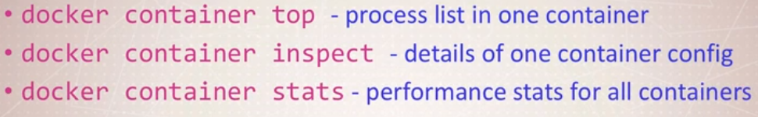

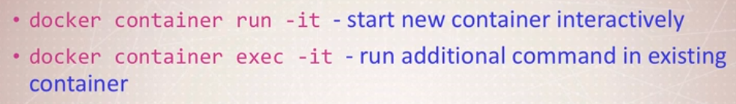

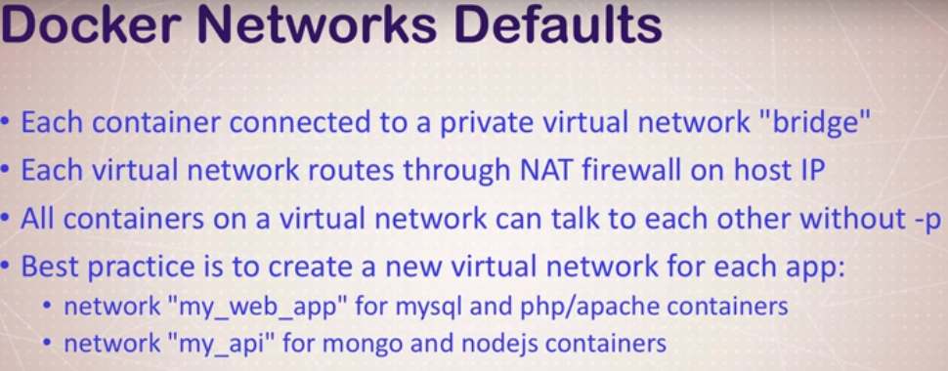

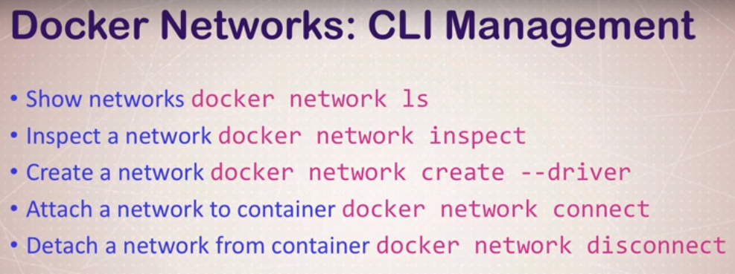

Create Network



or



Listing the network

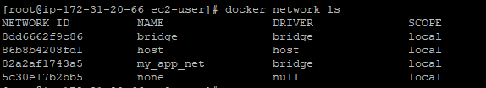

Inspecting the newly created my_app_net network :

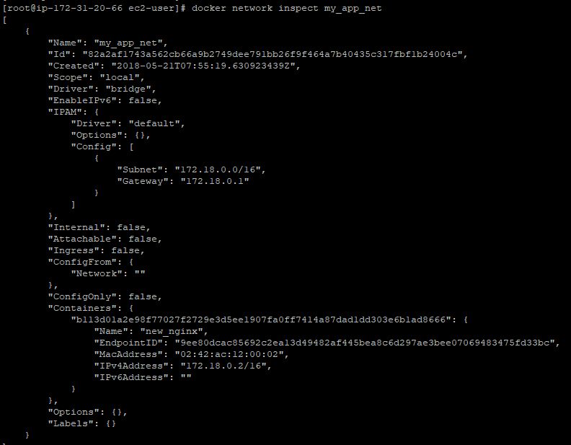

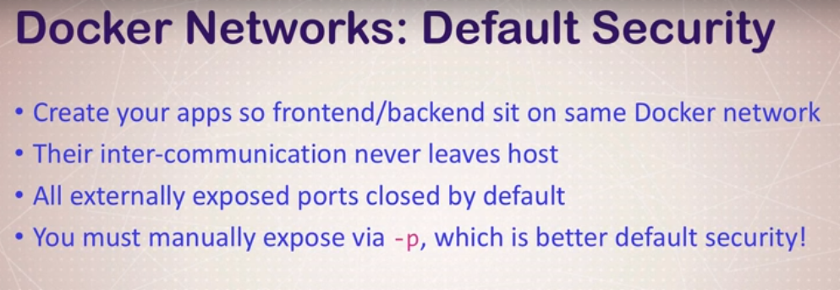

Add the other container to same network my_app_net



Check to verify

docker network inspect my_app_net

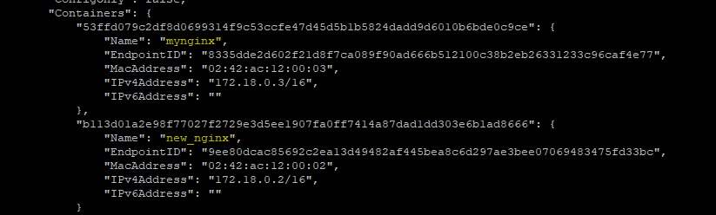

We can ping from one container to other within the same network without using any port

**Note:** If we ping and get the below error



Install iputils-ping

For that do the following :

docker exec -it mynginx bash

$ apt-get update

$ apt-get install iputils-ping

Now you can ping :

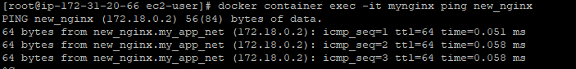

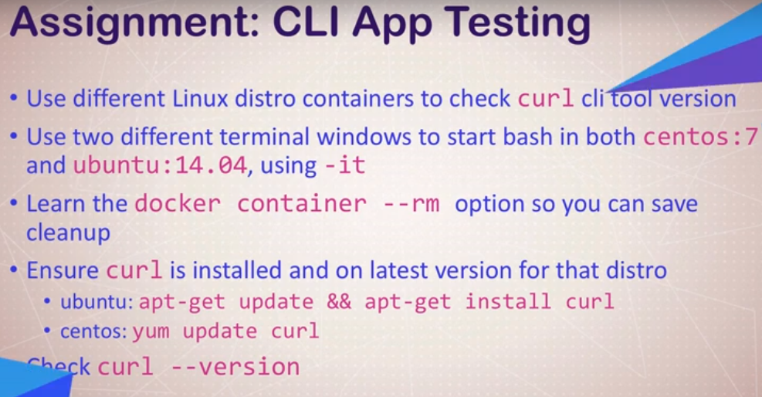

Solution:

docker container run –rm -it centos:7 bash

yum update curl

curl –version

docker container run –rm -it ubuntu:14:04 bash

apt-get update && apt-get install -y curl

curl –version



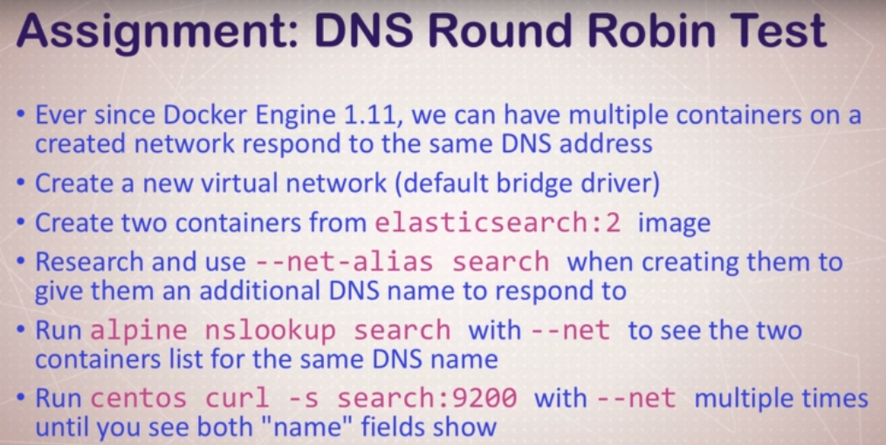

Solution:

Create network :

docker network create dude

Create 2 containers :

docker container run -d --net dude --net-alias search elasticsearch:2

docker container run --rm --net dude alpine nslookup search

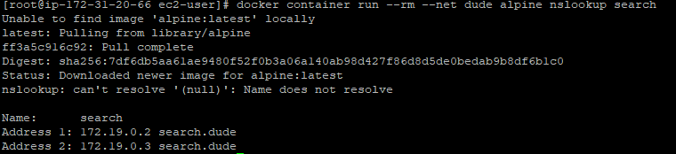

docker container run --rm --net dude centos curl -s search:9200

